Source https://deluxeiceland.is/luxury-tours/the-golden-circle-snorkeling/
__________________________________________________________

Golden Circle & Silfra Snorkeling Adventure
__________________________________________________________
★★★★★ 4.7/5 33 reviews

Add to wishlist ♡

__________________________________________________________

8-10 hours | From €727 per person

🏕  Image | 🏕  Image | 🏕  Image | 🏕  Image | 🏕  Image | 🏕  Image

__________________________________________________________
About This Tour
Experience Iceland’s Golden Circle like never before on this private day tour, which combines Iceland’s iconic natural attractions with an exhilarating snorkeling adventure in the Silfra fissure. Snorkel between two continents in one of the world’s clearest waters at Þingvellir National Park, then explore the geothermal wonders of the Geysir Geothermal Area and the stunning Gullfoss Waterfall. This tour offers a unique, personal experience and the flexibility to customize the day to your preferences.
__________________________________________________________
What’s Waiting for You
- Duration: 8 - 10 hours
- Group Size: Private group, ideal for families, couples, or small groups
- Languages Available: English
- Private Guided Tour: Fully personalized experience with your own expert guide
- Transportation: Luxury vehicle with Free Wi-Fi and bottled Icelandic water on board
- Season: Available year-round
__________________________________________________________

Check Dates & Availability

Select participants: (Age 99 and younger) - 1 +

Choose date:
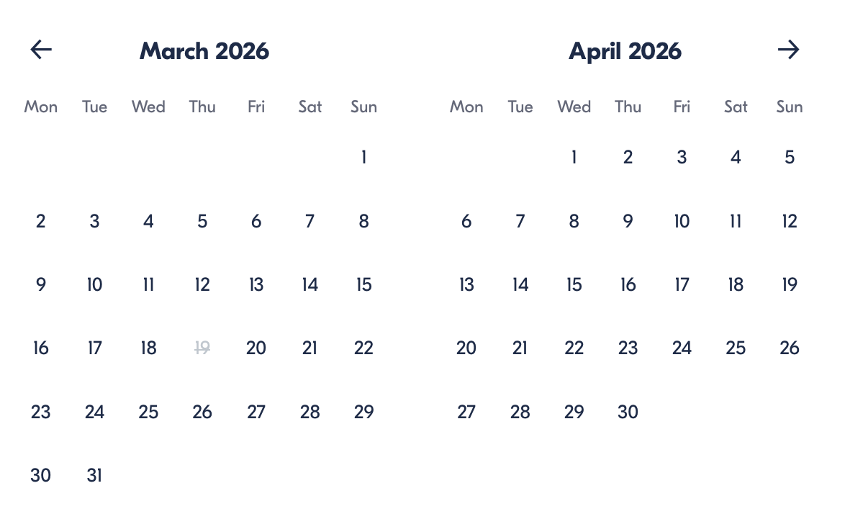

Check Availability

opens:

Participants: 2 March 16, 2026

Golden Circle & Silfra Snorkeling Adventure

- Duration: 8-10 hours
- Offered in: English
- Starts at: 10:30 AM

Cancellation:

- More than two weeks prior to arrival: 40% Credit / 60% Refunded
- Less than two weeks prior to arrival: 50% Credit / 50% Refunded
- Less than 72 hours prior to arrival: No refund and no credit

Price breakdown: 2 Participants x €727

Total: €1,454

The total price includes all taxes and fees.

Add to cart Book now

__________________________________________________________
Tour Features
- Snorkeling in Silfra: Swim in the crystal-clear waters between two tectonic plates in the Silfra fissure at Þingvellir National Park.
- Geysir Geothermal Area: Watch the famous Strokkur geyser erupt, sending hot water 30 meters into the air.
- Gullfoss Waterfall: Visit one of Iceland’s most stunning and powerful waterfalls.
- Private Vehicle: Travel comfortably in a luxury vehicle with free Wi-Fi and bottled Icelandic water.
__________________________________________________________
Detailed Itinerary
- Day 1 – Golden Circle & Snorkeling Adventure
Your day begins with a pickup from Reykjavik, where your private driver will take you to Þingvellir National Park. Here, you’ll experience an unforgettable snorkeling adventure in Silfra, the rift between the North American and Eurasian tectonic plates. The visibility is unparalleled, and the experience of swimming between two continents is truly unique. No certification is needed, just the ability to swim, as you’ll be provided with high-quality snorkel gear and a professional guide.
After snorkeling, your guide will take you on a light hike through Þingvellir to learn about the world’s first parliament and the area’s geological significance. From there, continue your journey to the Geysir Geothermal Area to witness the spectacular eruption of the Strokkur geyser, which erupts every few minutes.
Next, visit Gullfoss Waterfall, one of the most famous and awe-inspiring waterfalls in Iceland. The powerful water plunges in two stages, creating a magnificent sight and an excellent photo opportunity.
After exploring, your guide will return you to Reykjavik, where the tour ends.
__________________________________________________________
Included in Price
- English-speaking local guide for the entire tour
- Luxury vehicle with free Wi-Fi and bottled Icelandic water
- Private snorkeling tour in Silfra fissure
- All equipment needed for snorkeling
- Entrance fees to Þingvellir National Park, Geysir Geothermal Area, and Gullfoss Waterfall
- Private transfers between all destinations
- All taxes and fees – no hidden charges
__________________________________________________________
Not Included
- Meals (Lunches and dinners are not included)
- International flights
- Optional activities (snowmobiling, ATV tours, etc.)
__________________________________________________________

Cancellation Policy
For 5 or Fewer Participants:
- More than 2 weeks before arrival: 40% Credit / 60% Refund
- Less than 2 weeks before arrival: 50% Credit / 50% Refund
- Less than 72 hours before arrival: No refund or credit
For 6 or More Participants:
- More than 4 weeks before arrival: 40% Credit / 60% Refund
- Less than 4 weeks before arrival: 80% Credit / 20% Refund
- Less than 2 weeks before arrival: No refund or credit
Changes in the number of participants may increase the price per person. We recommend comprehensive travel insurance.
Weather-Related Cancellations:
If activities are canceled due to weather, they will be fully refunded. Itineraries may change based on conditions, with safety as the top priority.
Refund Processing:
Refunds are processed within 15 days after the tour ends.
__________________________________________________________
What Our Clients Are Saying

Overall rating  4.7/5  ★★★★★  Based on 33 reviews | Review summary  Guide 4.5/5  Transportation 4.6/5  Service 4.7/5  Organisation 4.5/5

Filter  - All traveller types  - Couples  - Group of friends  - Families  By star rating  - All star ratings  - 5 stars  - 4 stars  - 3 stars  - 2 stars  - 1 star | Search reviews (e.g., guide)  Sort by:  - Top picks  - Latest reviews  - Best ratings  - Lowest ratings
__________________________________________________________
★★★★★
Taryn – United Kingdom
The best way to see Iceland in one day! Snorkeling in Silfra was the highlight of our trip, and the Golden Circle was beyond amazing. Highly recommend!

★★★★★
Luca – Italy
Un tour fantastico! L'esperienza di snorkeling è stata unica, mai provata prima, e la nostra guida era incredibilmente preparata. È stata una giornata perfetta!

★★★★☆
Julie – France
Une journée incroyable! Le snorkeling dans Silfra était magique, et les paysages de la Route du Cercle d’Or étaient magnifiques.

See more reviews
__________________________________________________________

Meta tags

Page - Golden Circle & Silfra Snorkeling Adventure

Title: Golden Circle & Silfra Snorkeling Adventure | Travellio Global

Description: Discover the wonders of Iceland on a private tour of the Golden Circle and snorkeling in the Silfra fissure. Swim between two tectonic plates in crystal-clear waters, then explore Iceland’s most famous geothermal sites.

H1 - Golden Circle & Silfra Snorkeling Adventure
__________________________________________________________

